Object oriented programming
LAB FILE

NAME – VANSH MADAAN
BATCH- B4
SAP_ID- 500123857

ROLL_NO - R2142230412

Experiment-3
1) Write a Java program to count and display the total number of prime numbers between 1 and 1000.
public class Lab_3_first {
//write a program to count and display the total no of prime numbers between 1 and 1000.
public static boolean isPrime(int num) { for (int i = 2; i < num; i++) { if (num % i == 0) { return false;
}
}
return true;
}
public static void main(String args[]) { int count = 0;
System.out.println("prime nos b/w 1 and 1000 are:"); for (int num = 2; num <= 1000; num++) { if (isPrime(num)) {
System.out.print(num + " "); count++;
}
}
System.out.println("\ntotal no of prime no b/w 1 and
1000:" + count);
}
}
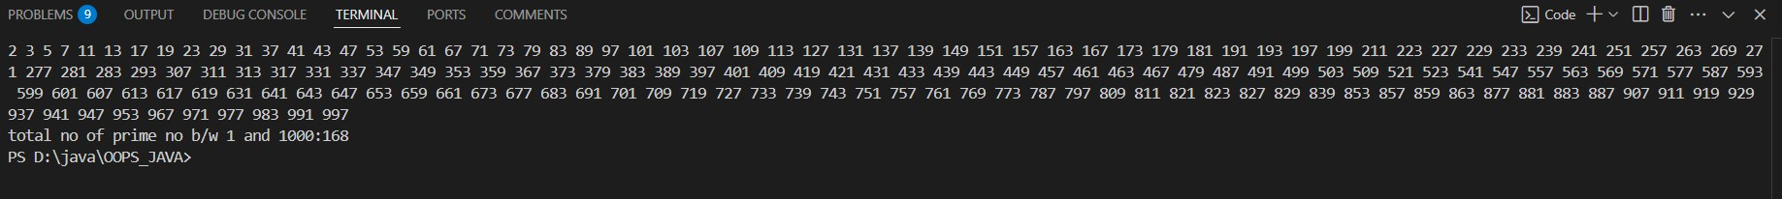
2. Given an array containing N-1 unique numbers from 1 to N, write a Java program to find the missing number.
Input: [1, 5, 6, 2, 4] Output: 3
public class lab_3_second { public static void sortArray(int arr[]) { boolean swapped; int n = arr.length; for (int i = 0; i < n; i++) { swapped = false; for (int j = 0; j < n - i - 1; j++) { if (arr[j] > arr[j + 1]) { int temp = arr[j]; arr[j] = arr[j + 1]; arr[j + 1] = temp; swapped = true;
}
}
if (!swapped) { break;
}
}
}
public static void main(String[] args) { int arr[] = {1, 5, 6, 2, 4}; sortArray(arr); int missing = -1; for (int i = 0; i < arr.length; i++) { if (arr[i + 1] - arr[i] > 1) { missing = arr[i] + 1; break;
}
}
if (missing == -1) { missing = arr[arr.length - 1] + 1;
}
System.out.println("missing numbers are: " + missing);
}
}
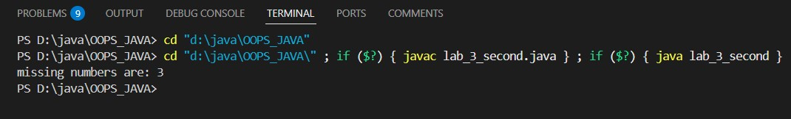
3. 1) Given an m x n matrix, return all elements of the matrix in spiral order.
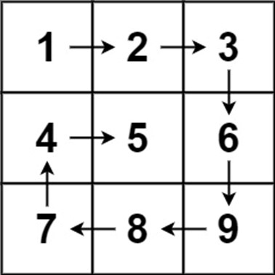
Input: matrix = [[1,2,3],[4,5,6],[7,8,9]] Output: [1,2,3,6,9,8,7,4,5]
public class lab3_third { public static int[][] spiral(int matrix[][]) { int m = matrix.length, n = matrix[0].length; int[][] spiralMatrix = new int[m][n]; boolean[][] visited = new boolean[m][n]; int top = 0, bottom = m - 1, left = 0, right = n - 1; int num = 1; while (top <= bottom && left <= right) { for (int i = left; i <= right; i++) {
spiralMatrix[top][i] = num++; visited[top][i] = true;
}
top++; if (top <= bottom) { for (int i = right; i >= left; i--) {
spiralMatrix[bottom][i] = num++; visited[bottom][i] = true;
}
bottom--;
}
if (left <= right) { for (int i = bottom; i >= top; i--) { spiralMatrix[i][left] = num++; visited[i][left] = true;
}
left++;
}
}
return spiralMatrix;
}
public static void main(String[] args) { int[][] matrix = {
{1, 2, 3},
{4, 5, 6},
{7, 8, 9}
};
int[][] spiralMatrix = spiral(matrix); System.out.println("Spiral Matrix:"); for (int i = 0; i < spiralMatrix.length; i++) { for (int j = 0; j < spiralMatrix[i].length; j++) {
System.out.print(spiralMatrix[i][j] + "\t");
}
System.out.println();
}
}
}
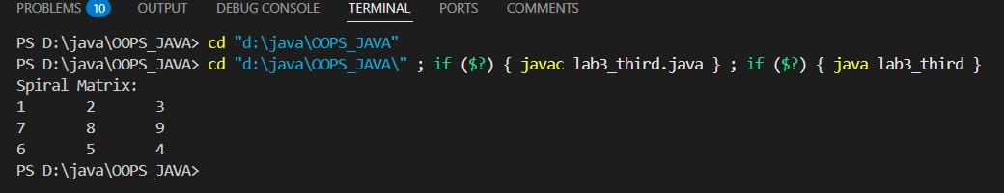
4. G iven two strings s and t, return true if t is an anagram of s, and false otherwise.
Example 1:
Input: s = "anagram", t = "nagaram"
Example 2:
Input: s = "rat", t = "car"
Output: false
Output: true
=>
public class lab3_fourth { public static boolean isAnagram(String s, String t) { // If lengths are not equal, they cannot be anagrams if (s.length() != t.length()) { return false;
}
int[] charCount = new int[26]; for (int i = 0; i < s.length(); i++) { charCount[s.charAt(i) - 'a']++; charCount[t.charAt(i) - 'a']--;
}
for (int i = 0; i < 26; i++) { if (charCount[i] != 0) { return false;
}
}
return true;
}
public static void main(String[] args) {
String s1 = "anagram";
String t1 = "nagaram";
System.out.println(isAnagram(s1, t1)); String s2 = "rat";
String t2 = "car";
System.out.println(isAnagram(s2, t2));
}
}
